

**SURVEILLENCE AND GSM HOME BASED SECURITY SYSTEM**

**BY**

**BAKARY BADJIE**

A dissertation submitted in partial fulfilment of the requirement for the degree of Bachelor of Science

In

Electrical and Electronic Engineering

2nd January 2020

Supervisor:

Asst. Prof. Dr. Burcin Özmen

*To my parents,*

*Ousman and Kumba Badjie*

*This article (project proposal) is dedicated to my father who showed me that, the best way to achieve whatever you desire for is by self-discipline, respect for all, tolerance, dedication, hard work, and prayers. It is additionally devoted to my mother, who gave me the understanding that even the biggest undertaking task can be proficient on the off chance that it is done with extra care.*

**Abstract**

The paper talks about the improvement of security at home and other important facilities and checking conventional security frameworks that are worried about controlling any kind of intrusion situations and social occasion. Security is a fundamental need for any environment. A parcel of Security organizations is accessible towards shielding the necessary places from being vandalized or something like that.

This project (security system), aims to serve as simple but very effective home security system that has a function of texting the user on his/her mobile phone in case of any intrusion situation. The invention of this project includes; the Passive Infrared (PIR) sensor, Arduino UNO, Global System for Mobile communication (SIM900 GSM) module, OV7670 Camera Module and SD Card Module. In today’s context, it is common to leave the home unattended, as people are busy catching up with their tight schedules. Therefore, most people have chosen this security system as the most reliable way to protect their homes.

All body generates some heat energy in the form of infrared, which is invisible to human eyes, but an electronic sensor like the PIR sensor can detect it. PIR sensor detects any living being motion using the concept infrared radiation then it logical output goes high and triggers the Arduino by sending in the logical information to the Arduino, then the Arduino communicate with the GSM module via TTL serial communication, and the GSM module converts the serial data into electromagnetic signal and send an alert to the programmed mobile phone number in the system in a form of text messages, using the principles of cellular communication.[3] The OV7670 camera module captured the image of the moving body using the concept of digital image processing.

**Declaration**

I understand the nature of plagiarism, and I am aware of the University’s policy on this

I certify that this project proposal reports is originally written by me during my university project proposal except for that which is stated below.

The preview of this report is largely taken from the following books stated below and those mentioned in the references section.

* Focusing devices for pyroelectric infrared sensors [Online]. Available from: <http://www.glolab.com/focusdevices/focus.html> [accessed Sep 22, 2017].
* Dhake PS, Borde SS. Embedded Surveillance System Using PIR Sensor. International Journal of Advanced Technology in Engineering and Science. 2014 Mar; 2 (3).
* Akaiwa, Y. (2008) Introduction to Digital mobile communication, 2nd Edition. ISBN: 978-1-119-04110-8 (June 12, 2016) [Online]
* Michel. M and Bernadette. P (2002) GSM system for mobile communication 2nd Edition
* Simon. M. (2013) 30 Arduino project for Evil Genus second Edition
* Massimo B. (2008) Getting Started with Arduino 1st Edition

**Signature:** BAKARY BADJIE **Date:** 2nd.12.19

**Acknowledgements**

First, I want to thank Almighty Allah for allowing me to reach at this stage in my academic career. It gives me a great sense of pleasure to present these report of my graduation project, which is a fulfilment of the requirement of my bachelor of science in electrical and electronic engineering in the European University of Lefke (EUL).

I owe special debt of gratitude to Professor Dr. Sadik Ülker my course advisor who is also the dean of faculty of engineering, Assistant professor Dr. Burçın Özmen head of the department of electrical and electronic engineering, who is alsomy project supervisor, for their constant support and guidance throughout the course of this report in all aspects. Their sincerity, thoroughness, and perseverance have been a constant source of inspiration for me. It is only their cognizant efforts that my endeavours have seen the light of the day.

I also do not want to miss this opportunity to acknowledge the contribution of all the staffs of the department of electrical and electronic engineering for their endless support, excellent and an understandable academic delivery from day one of my studies in the European University of Lefke up to date. I also owe a debt of gratitude to myfamily for their continuous prayers and that my employee the Gambia National Army for having confidence in me to send me in the European University of Lefke to pursue my ongoing bachelor degree in electrical and electronic engineering and for funding my entire studies and my stay in North Cyprus.

**Table of Contents**

**Bakary Badjie………………………………………………………………………ii**

**Abstract……………………………………………………….…………………....iii**

**Declaration……....…………………………..……………………………………..iv**

**Acknowledgement…….…………….…….……………………………………..….v**

**Table of Contents……….………………………..……...………………………....vi**

**List of Figures ……....…………………….………………………………….…...ix**

1. **Introduction ………..……………………………………………….………...2**
   1. Background and Context……….……………………………………..3
   2. Scope of the Project……………….…………………………...……..3
   3. Aims and Objectives………..……....….……………………………..3
   4. Usage of The Project………………………...……………....………..4
   5. Achievements…..……………………………..……………………...4

1.6 Overview and Dissertation……………...……………………...…….4

**2.0 Technical background of THE Project…………………………6**

**2.1 Technical Description and Working Principles Passive Infrared (PIR)**

**…………………………………………………………………………6**

* + 1. Working Principle of PIR Sensor…...……………………………6
    2. Features of PIR Motion Sensor………...…………………………8
    3. PIR Sensor’s Pins Descriptions…………………...………………8
    4. PIR Sensor Sensitivity Adjustment………………...……………..9
    5. Delay Time Adjustment of the PIR Sensor……….………………9
  1. **Technical Descriptions and Functions of Arduino UNO..……………10**
     1. Functions and The Working Principles of Arduino UNO………..11
     2. General Pin Functions of Arduino UNO……....…………………11
     3. Special Pin Functions………...…..………………………………12
  2. **Technical Descriptions and Functions SIM900 GSM Module………..13**
     1. Working Principles of SIM800 GSM Module……………….......13
     2. “AT” Command…….….…………………………………………14
     3. GSM Architecture……,,,,………….…..…………………………14
     4. Cell…………………………….….....……………………………15
     5. Basic Structure of a Communication System and its Operation.…16
     6. Base Transceiver Station (BTS)………………......………………16
     7. Base Station Controller (BSC)…………………...….,…,…………17

2.3.7.1 Main Functions of The Base Station Controller……..…,,………17

* + 1. Mobile Switching Centre (MSC)…...;…...……….…………..……18
    2. GSM Network………………………….…………………….…….18

2.3.9.1 Types of Channels in GSM Network.....................….……...…...18

2.3.9.1a Control Channel…………..…………………… ………18

2.3.9.1b Traffic Channel or Voice Channel………………………19

2.3.10 Signal Range……………….………………..………………………19

2.3.10.1 Power Calculations………....… ………………………19

2.3.10.2 Frequency Reuse…………...….…….…………………19

2.3.11 Multiple Access Protocols……….….………………………………20

2.3.11.1 Time Division Multiple Access (TDMA)………...……20

2.3.11.2 Code Division Multiple Access (CDMA)…..…………20

2.3.11.3 Frequency Division Multiple Access (FDMA)…..……20

* + - 1. Space Division Multiple Access (SDMA)……............20

**2.4 Technical Descriptions and Functions of 0V7670 Camera Module21**

**……………………………………………………………22**

* + 1. Camera module Specifications………..……...…...……….22
    2. Applications of Camera Module (OV7670)…………..…22
    3. Functions of The OV7670 Camera Module…...……..……22
  1. **Technical Description and Functions of SD Card Module…....23**
     1. Functions of the SD Card Module………………….…….23

2.5.2 Features of SD Card Module….......................……...……23

**2.6 Methodology…….…………….……………………….…………23**

2.6.1 Interfacing PIR Motion Sensor with Arduino UN...…;..…23

2.6.2 Interfacing GSM Module with Arduino UNO ……………24

2.6.3 Interfacing OV7670 Camera Module with Arduino UNO...25

2.6.4 Interfacing SD Card with Arduino………..…….…………26

2.6.5 Concept and Operations of The System………..….………27

2.6.6 Block Diagram of The System….…………………………28

2.6.7 Circuit Diagram of The System …….……….…… ……...29

2.6.8 Academic Honesty and Plagiarisms……...………………..29

2.6.8.1 Cheating…...................................................................29

2.6.8.2 Plagiarisms…….…..…………..….………………….29

1. **Social Effects of The project……………………….………...30**

3.1 Economic Analysis………….…...…….………………………30

* 1. Manufacturing…………..….…………………………………31
  2. Sustainability………………………………………………….31
  3. Health and Safety……….…………………………………….31
  4. Ethics……………...…..………………………………………32
  5. Legal Issues…………..……….………………………………32

1. **Result and Discussion……………………………………..…33**

4.1 Advantages……………………………………………………33

4.2 Problems and Solutions……………………………………….34

1. **Conclusion…...……………………………..…………………37**
   1. Summary………..........…………………………………..………37
   2. Evaluation………………….……………….……………………37
   3. Future Work…………...…………………………………………38

**References………………..………………………………………39**

**Appendix………...…...……………………..……………………40**

**List of Figures**

**Figure No. Name of Figure Page No.**

Figure 2.1. Diagram of PIR Sensor Module…………………………………...6

Figure 2.2. Sketch Diagram of How PIR Sensor Detect Motion ThrougChange

In Environment…………...…….………………………........…....7

Figure 2.3. PIR Sensor’s Motion Detection Demonstration………….....…….7

Figure 2.4. Diagram of The Sensitivity Adjustment of The PIR Sensor….......9

Figure 2.5. Diagram of The Delay Time Adjustment of The PIR Sensor….......9

Figure 2.6. Diagram of Arduino UNO……………………………………….10

Figure 2.7. Diagram of the GSM Architecture…………...…..……………....15

Figure 2.8.1. Diagram of The Geographical Cell of Cyprus……..…..……….15

Figure 2.8.2. Diagram of The Base Transceiver Station in a Cell…………….15

Figure 2.9. Diagram of The Basic Structure of Cellular Communication Sys16

Figure 2.10. Diagram of a Base Transceiver Station (BTS) ………….……....17

Figure 2.11. Diagram of a Mobile Switching Centre (MSC)…...……....…….18

Figure 2.12. Diagram of the Camera Module (OV7670)…………...………...21

Figure 2.13. SD Card Module…………...……………...……..……..……….22

Figure 2.14 Interfacing PIR Motion Sensor with Arduino….……………..…24

Figure 2.15 Interfacing SIM900 GSM Module with Arduino……………......25

Figure 2.16 Interfacing OV7670 Camera Module with Arduino…...……...…25

Figure 2.17 Interfacing SD Card Module with Arduino….…..........................26

Figure 2.18 Picture of The Complete System…………..………….................27

Figure 2.19 Block Diagram of The Security System ………………….….….28

Figure 2.20 Systematic Diagram of The Security System…………….……...29

Figure 4.1 Results…………………………………………………………...36

**1.0 Introduction**

Innovative technologies are being developed by people to improve the quality of human lives in this age, and all are using technological advances in many ways. One of the ways is security System. In golden days, people secure their homes and other places by using the locks and keys. A due unsecured environment, such system can be easily be broken and owners are aware of it. Today in the modern world, the security measures are a very important factor regarding its safety. Therefore, the security level has moved on to the next level where all the control regarding the lies is regulated by the Owners hand. Researchers have been conducted regarding the automated and security of the homes and other facilities. One of the main developed systems is Home Security System, which is a most superior protective device in the recent world. It is a paramount home security, which provides affordable, genuine and effective at the same time in this fast moving competitive world.[1] In this modern developed network society, each individual can access their information easily anytime from anywhere. On the other, they can face the risk that others can also hack into their personal and their sensitive information.[1] Due to this risk personal identification technology can differentiate between authorized and imposters, which is now generating great interest among users. Generally, for the sake of purposes, various security measures like PIN verification, identification card techniques are being used but currently, it can be mishandled and hacked. Due to the difficulty faced by the current home-based security and surveillance, systems in providing information to the situation while the users being away from home. This paper we have discussed and tried to overcome this project which provides implementation of different features in the home security along with control of home automation using mobile and also provide user to add extra devices that provide them to keep track and record of intruder and direct alert message to corresponding following secure medium to ensure the very first safety towards environment. This article talks on the hardware and software design, the implementation, and working of individual components and the overall functioning with a conclusion and its future work.

**1.1 Background and Context**

This security system works regularly by detecting movements, sending an alert to the user in a form of text messages, and storing images as well as displaying them on the user’s screen. Therefore, it transmit signals to a nearest base transceiver station. A large number of base stations in a city/town of any size are required to support this operation because it uses a cellular network in which large number of user also utilized. Each carrier in each city also runs one central-office called the Mobile Switching Centre (MSC), which handles all the mobile phone connections to the normal land based phone, and controls all the base station in the region (Miao 2016).

**1.2 Scope of The Project**

This project is composed of three subsections, which are the intruder detection system that is carryout by the passive infrared sensor (PIR) in a process of infrared radiation, the Arduino UNO board that consist of the microcontroller that is responsible for the embedded applications and the SIM900 GSM module. In case of intrusion attempt, the SIM900 GSM module is responsible to send text message to the user’s mobile phone using the concepts of cellular communication, the 0V7670 camera module is used capturing image and send the image in the SD card to store the image of the intruder.

#### **1.3 Aims and Objectives**

The main aim and objectives of this project to provide security and safeguard the environment where applicable. The following aims and objectives are been achieved.

* The system meet the criteria for being suitable for human usage in the present generation.
* The system is able to withstand human intrusion or invasions
* The system being a source of complete safe and controllable monitoring system for the users by providing them with the best security system.
* Finding key results and presenting those results to the audience based on my research, implementations the understanding of the project.
* As a source of fulfilment of the partial requirement of my Bachelor of Science degree in Electrical and electronic engineering

**1.4 Usage of The Project**

* The PIR sensor and GSM security system can be accessible from everywhere whether at home or not.
* It can be applicable in hospitals supermarkets, banks safe rooms, presidential palace, military barracks to provide a controllable security.
* The system is stable and reliable thus can strengthen the protection for public, private and commercial facilities
* This system is independently powered. It skip battery power; therefore have a backup Power meaning even if the power in the house or any other installed place went off, the devices can still work.
* As the system comprises of an embedded applications, it cannot be physically tempered by anyone to reverse it function or to stop working except by changing the programming aspects of it.
* In today’s context, the system uses a wireless connection to communicate to the user and does not share with any other service like the internet, satellites disks or televisions. Wireless connection in this context does not need internet connection but cellular communication technique to function.

**1.5 Achievements**

* Provision of security within a range of 7-20 meters
* It saves electrical energy as it uses 5-9VDC
* It operates on 2G network and do not interfere with other signals
* It do not stop other devices from working on any frequency spectrum
* Alert the user at any point in time in the case of intrusion.

**1.6 Overview and Dissertation**

This security system was initially implemented for the security agencies to control the intrusion circumstances, but nowadays it is a commonly used system for both government and security installations for a means of suitable security provision.

Generally, this security system stops any intruder invading a place without the knowledge of the concern person by sending an alert to the concern person or to the police by sending a text message and capturing the image of the intruder. This device works in a similar frequency at which the GSM network works in transmitting messages from one user to another. The security achievement is the point at which an intruder can easily be apprehended by alerting the concern person and capturing the image of the invader and makes the investigation of the police easier.

**2.0 Technical Background of The Project**

**2.1. Technical Descriptions and Working Principles of The Passive Infrared (PIR) Sensor**

Passive infrared (PIR) sensor is a photoelectric device that detects motion. Hence, it is call motion detection sensor. It detects motion by sensing the changes in infrared levels emitted by nearby living being. The PIR measures infrared (IR) light radiating from object in it range of field of view or detection. They are often used in PIR based motion detectors like to the used in my project.

PIR becomes a motion sensor when it is configured in a differential mode, in which if a human movement is detected within its line of sight, a pair of complementary pulses are preceded at the output pin of the PIR sensor.

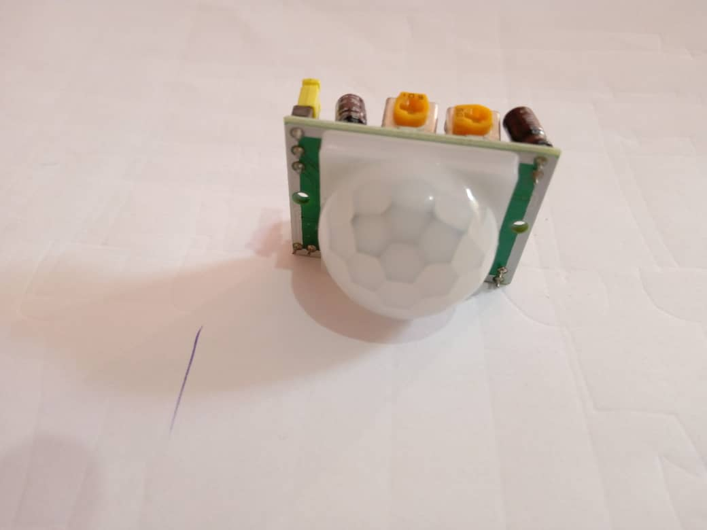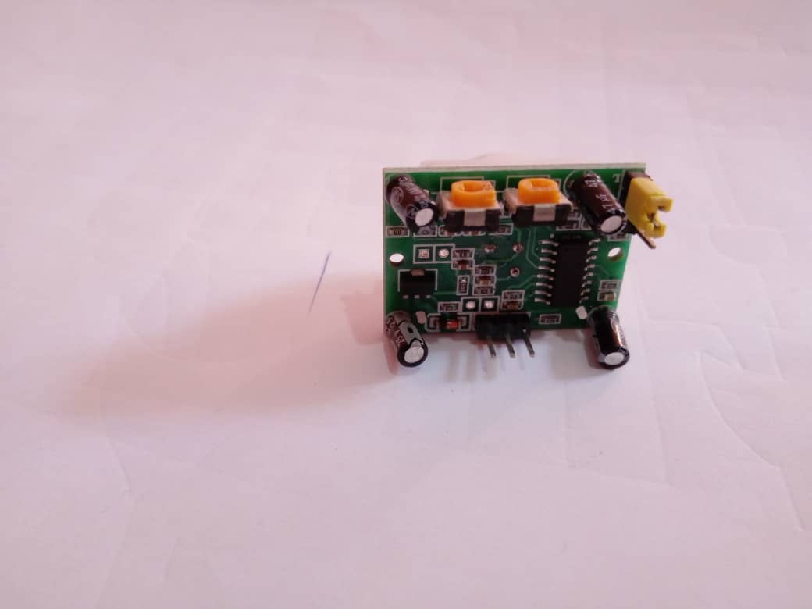

Fig 2.1. PIR sensor module [4]

**2.1.1 Working Principle of PIR Sensor**

All living being with a temperature above absolute zero emits heat energy in the form of radiation. PIR sensor is made of ceramic materials that generate surface charges when exposed to infrared radiations. As the amount of radiation increases, the surface charge generates increases. When living being come in range of the PIR sensor, it detects heat of that living being and generates an output. PIR sensor module do not send any rays for detection, it only detects heat (Infrared). Passive elements are those that do not generate their own voltage or energy. A FET is used to buffer this signal. As the sensor is sensitive to a wide range of radiations, a filter is used which limits the infrared rays falling on the sensor 8μm to 14μm range. The field of views of this sensor is an area of zone which it sees or where changes in the infrared radiation can be sensed or detected.

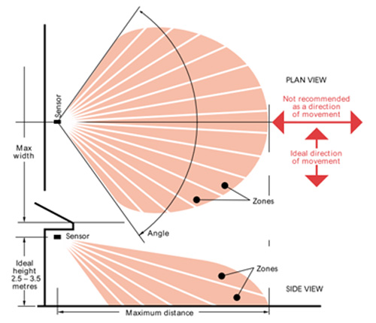

Fig 2.2 Sketch diagram of how PIR sensor detect motion through change in environment [1]

Typically, to enhance the range and field of view, the field of view is divided into number of zones (both vertically as well as horizontally) with the help of Fresnel lens, a Fresnel lens is a Plano convex lens that is collapsed on itself to form a flat lens which retains its optical properties, but is thicker thinner and lesser absorption losses.

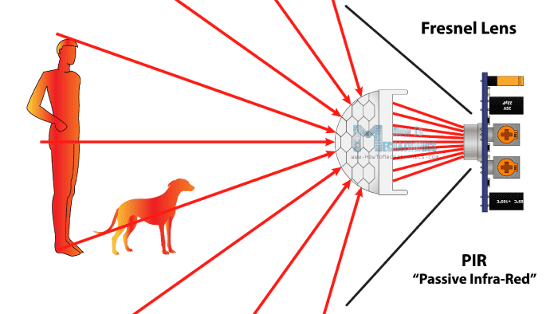

Fig 2.3 PIR infrared motion detection demonstration [4]

**2.1.2 Features of PIR Motion Sensor**

1. Detect human motion
2. Detection angle of 120 degrees.
3. The detection range of 7 m.
4. Size: 32x24mm
5. TTL switch signal output high signal output (3.3V), a low signal output (0.4V).
6. The trigger time is adjustable 0.3 seconds to 10 mins
7. commonly used in security projects/devices
8. Has a reusable trigger.
9. 4.5 to the 20V working voltage

**2.1.3 PIR Sensor’s Pins Descriptions**

1. Pin #1 is the power supply pin which is always connected to +5VDC
2. Pin #2 is the output pin and is always used as the output signal pin for the PIR.
3. Pin #3 marked as the GND pin. This pin is used to provide ground to internal circuit of the PIR sensor.

**2.1.4 Triggering Modes of The PIR Sensor**

PIR sensor also consists of a trigger mode. The **“**Repeated trigger mode” or **“**Unrepeated mode”.The jumper is used to control the trigger mode. When the jumper cap is at the low position, the mode is set up as **“**Unrepeated trigger mode”, which means when the module is outputting an HIGH voltage because of human motion it will not be triggered again even if another human motion is detected. When the jumper cap is at high position, the module is setup as “repeated trigger mode”, which means the delaying time will be recalculated when a second human motion is detected during its delaying time

**2.1.5 PIR Sensor Sensitivity Adjustment**

As mentioned, the adjustable range is from approximately 3 to 7 meters. The illustration below shows how the adjustment is done.

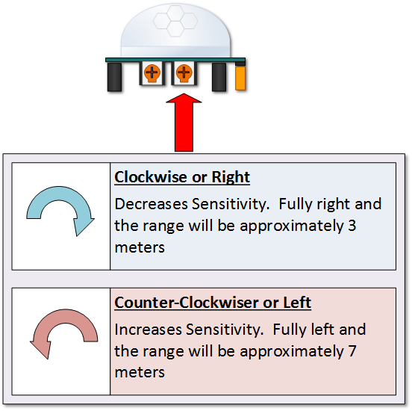

Fig 2.4 Explanations of the sensitivity adjustment of the PIR motion sensor [4]

**2.1.6 Delay Time Adjustment**

The time delay adjustment determines how long the output of the PIR sensor module will remain high after detection. The range is from about 3 seconds to 5 minutes. The illustration below shows is delay adjustment.

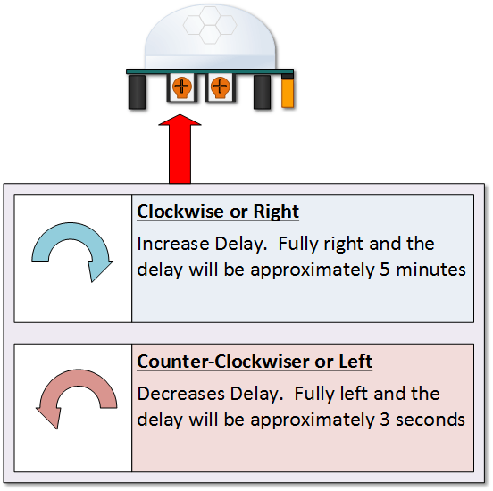

Fig 2.5 Explanations of delay time adjustment of PIR motion sensor [4]

**2.2. Technical Descriptions and Working Principles of Arduino UNO**

Arduino is a physical computing platform for managing and handling electronics. It is an open source platform-independent IDE that facilitates programmer to process the electronics signal from the attached components and control them. It consists of 8-bit Atmel AV microcontroller clock speed 16 MHz freeware and a very active developer community. The board is equipped with 14 digital pins, 6 analogue pins and programmable with the Arduino IDE (Integrated Development Environment) via a type B USB cable. It can be powered by a USB cable or by an external 9 volts battery, though it accepts voltages between 7 to 20 volts. It also consists of a Voltage regulator crystal oscillator.

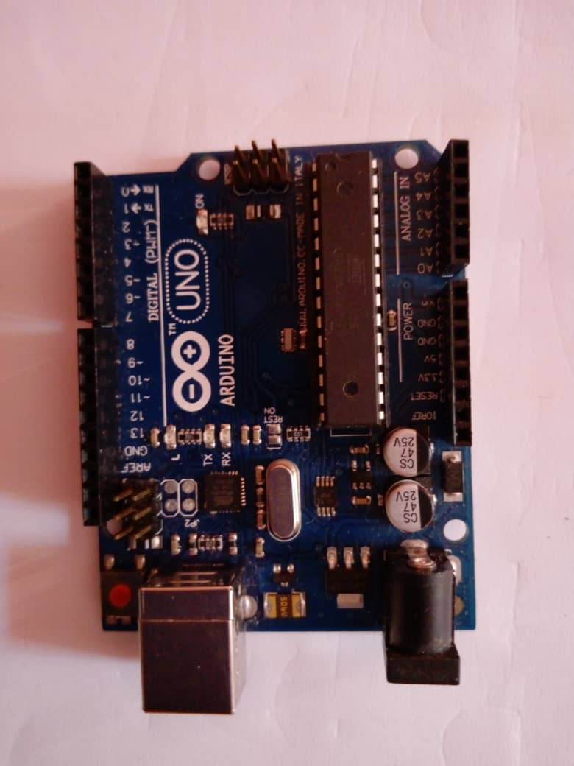

Fig 2.6 Arduino UNO Board [7]

Arduino program contains two main parts; Setup() and Loop().The name of the function implies their purpose and activities. Setup()programsets up the Arduino hardware, such as specifying I/O lines is planned to use, and whether they are inputs or outputs.

**2.2.1 Functions of Arduino UNO in Respect to The Project**

Arduino is interfaced between the PIR sensor and the GSM module and performed the following functions;

* It receives a logic signals from the output of the PIR sensor as its input and convert it to a serial data.
* It processes the logical signals with the help of the microcontroller-embedded system.
* Communicates with the GSM module via its serial pins and sends the “AT Command” to the GSM module to initialize a call and text message to a prescribed mobile number through the “CUI Command” and “TUI Command” respectively in a process of serial communication.
* Stored data (pictures and videos) in the SD card.

**2.2.2** **General Pin Functions of an Arduino UNO**

* LED:There is a built-in LED driven by digital pin 13. When the pin is at HIGH value, the LED is ON, when the pin LOW, the LED is OFF.
* VIN: The input voltage to the Arduino board when it is using an external power source (as opposed to 5 volts from the USB connection or other regulated power source).
* 5VDC**:** This pin outputs a regulated 5 volts from the regulator on the board. The board can be supply with either from the DC power jack (7 to 20V), the USB connector (5V), or the VIN of the board (7 to 20V). Supplying voltages via the 5V or 3.3V pin bypasses the regulator, and can damage the board.
* GND: Ground pins
* IOREF: this pin on the Arduino board provides the voltage reference with which the microcontroller operates.
* Reset: Typically used to add a reset button to shields, which block the one on the board.

**2.2.3 Special Pin Functions of an Arduino UNO**

Each of the 14 digital pins and 6 analogue pins on the UNO can be used as an input or output, using pinMode(), digitalWrite() and digitalRead() functions. They operate at 5Volts. Each pins can provide or receive 20mA as recommended by the operating condition and has an internal pull-up resistor (disconnected by default) of the 20K to 50K Ohms resistor.

A maximum of 40mA is the value that must not be exceeded on an I/O pins to avoid permanent damage to the microcontroller. By default, they measured from ground to 5 volts. Though it is possible to change the upper end of their range using the analogReference() function.

In addition, some pins have specialized functions.

* Serial/UART:Pin 0(RX) and 1 (TX) used to receive (RX) and transmit (TX) TTL serial data. These pins are connected to the corresponding pins of the ATmega8U2 USB-to TTL serial chip.
* External Interrupts**:** (Pin 2 and pin 3) can be configured to trigger an interrupt on a low value, a rising, or a falling edge, or a change in value.
* Pin 0, 1, 2, 3, 4, 5, 6, 7, 8, 9, 10, 11, 12, **13** can only be use as digital inputs and outputs except for pin o and 1 which are used for TX and RX as mention above.
* Pin A0, A1, A2, A3, A4, A5are the used as both analogue and digital inputs and outputs.
* PWM (Pulse Width Modulation): pins 3, 5, 6, 9, 10 and 11 provides 8 bits PWM output with analogWrite () function.
* SPI (Serial peripheral Interface):10(SS), 11(MOSI), 12(MISO), and 13(SCK). These pins support SP pins communication using the SPI library.
* TWI (Two-Wire Interface) I2C**:** A4 or SDA pin A5 or SCL pin support TWI communication using the wire library.

**NOTE:** Some pins have multiple purposed (Crystal can be used as PB6, PB7).

**2.3 Technical Descriptions and Working Principles of SIM900 Global System for Mobile Communication (SIM900 GSM) Module**

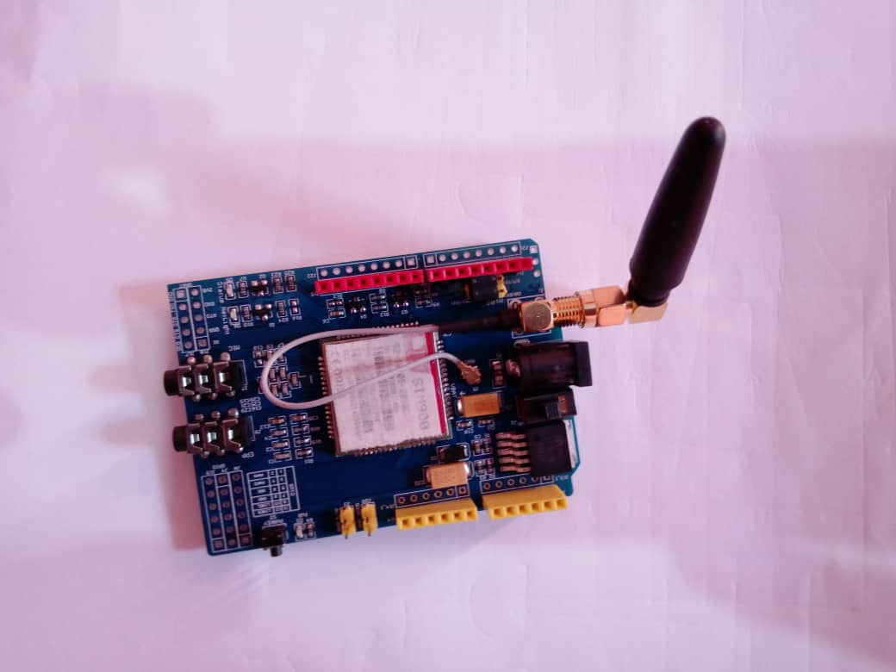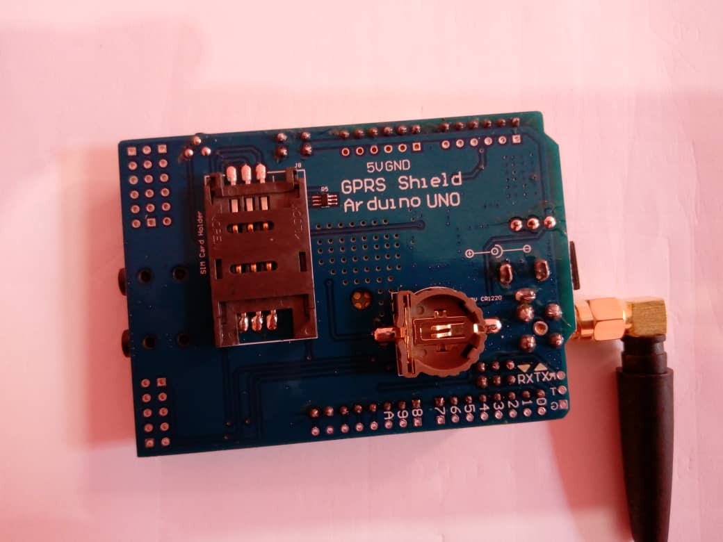

Fig 2.7 SIM900 GSM module [6]

GSM module is a specialized type of modem, which accepts Subscriber Identity card (SIM card) and operates over a subscription to a mobile operator just like a mobile phone from the mobile operator perspective. When GSM is connected to a computer this allows the system to use the GSM modem to communicate over a mobile network. It is used to make the development process easier and faster. A wireless module that consists of ultra-compact can support voice, data and fax at both 900 and 1800 MHz This is low power device which has a tiny size of 24mm * 24mm * 3mm which helps in putting it with an Arduino controller on a breadboard with small size box.

GSM module is a GSM module connected to Arduino with different types of outputs taken from the board-say TTL output (for Arduino UNO Microcontroller) and RS232 output to interface directly with Arduino, The advantages of using the GSM module in my project is that it RS232 port to communicate and develop embedded signal from the microcontroller of the Arduino to make the data transfer from the Arduino to the GSM module easy. It also help in the sending of the SMS and to the prescribed mobile phone number.

**2.3.1 Working Principle of SIM900 GSM Module**

The GSM module (SIM900) received serial data from the serial port of Arduino UNO through a serial commands in a process of RS232 serial communication converts it to an electromagnetic signal, and transmit the electromagnetic signals through its antenna to a nearest base transmitting station using the text commands, then to the Base Controlled Centre, then to the Mobile Switching Centre and finally to the base transmitting station near the user’s location which delivered the signals to the user’s mobile phone in a form of text message using the technique of cellular communication.

To make sure the GSM module perform its required functions i.e. to send SMS, it must be interfaced with the Arduino UNO to receive the serial commands.

**2.3.2 “AT” commands**

These instructions commanded the module. AT is the abbreviation of Attention. All commands start with “AT.” That is why it is called “AT “command. AT is the prefix each command inform the module about the start of the command.

The GSM module uses the following command to initialize the text messaging process.

* “**AT+CHFA=1”** This command is used to select the Arduino channel
* “**AT+CMIC=1**” This command is used to select the gain of Arduino, its value is between 0-15.

**2.3.3 GSM Architecture**

As mentioned above, this section illustrates how GSM module communicates to the prescribed mobile phone number, which is programmed in the system and explains the concept of cellular concept, features of cellular concept, which involves frequency, re-use, cell-splitting, handoff procedures. When the GSM module have to send SMS to the mobile phone, it just deliver the SMS to the mobile phone but has anyone wondered how these SMS are delivered?, what exactly happens when the serial data from the Arduino are fed into the GSM module to send SMS to the prescribed mobile phone number?. The GSM module works exactly the same way a mobile phone work as far as mobile communication is concerned. Let start with the cellular concept.

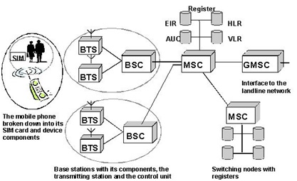

Fig 2.8 Diagram of GSM Architecture [6]

**2.3.4 Cell**

The GSM module can make calls and send SMS from one part of the country to another part, technically, every city is divided into smaller areas called as a cell thus a cell is defined as the basic geographical unit of a cellular communication system, as the city is geographically divided into smaller cells it is mandatory that all cell must be symmetric in shape such as hexagon because it has highest area compare to other shapes.

When joined together, these cells provide coverage over a wide range of geographical areas. This enables a large number of portable transceivers such as mobile phone, GSM module, etc. to communicate with each other and with a fixed transceivers and telephones line anywhere in the network.

 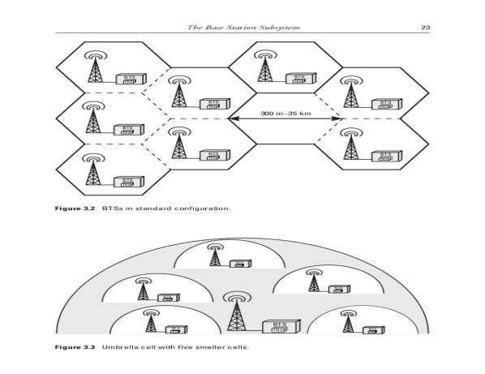

Fig 2.9.1: Geographical cell of Cyprus Fig 2.9.2 Base transceiver station in a cell [6]

**2.3.5 Basic Structure of a Cellular Communication System and Its Operational Principles**

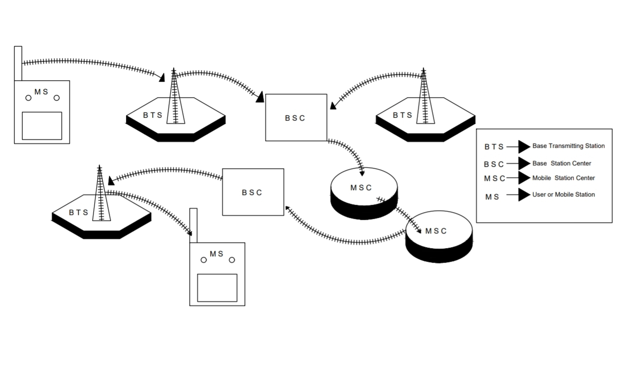

Fig 2.10 Basic structure of a cellular communication system [8]

In the diagram above, Mobile station (MS) is nothing but a mobile phone of a user. Every cell has its own base transceiver station at its centre, whenever a call is setup by the GSM module, the first signal is transmitted to the base transceiver station of the cell, the transceiver station transmit the received signal to the central base station controller (BSC) which controls the transmission and reception of all base transceiver stations in the area, from BSCthe signal is further sent to the Mobile Switching centre (MSC) which is the master controller of the entire system, MSCs are different for different areas. From MSC of area one, the signal is transmitted to the MSC of area two where it follow the reverse sequence as, MSC to BSC to BTS and from BTS to the MS of area two.

**2.3.6 Base Transceiver Station (BTS)**

A Base transceiver station (BTS) is that, which communicates with the mobile or the GSM module by transmitting a signal to the GSM Module or receiving a signal form the GSM module. Most BTSs are usually placed at the centre of a cell; its transmitting power defines the cell size.

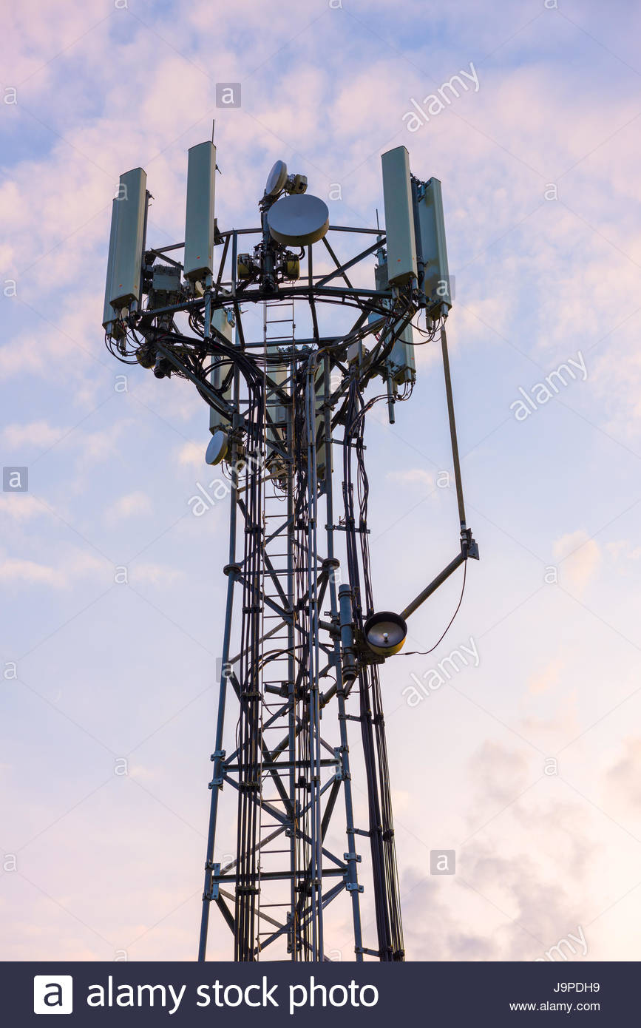

Fig 2.11 Diagram of a Base Transceiver Station [6]

**2.3.7** **Base Station Controller (BSC)**

Base Station Controller (BSC) is a high limit switch with a radio communication and versatility control abilities. The capacity of base station includes radio channel designation, location update, handover, timing advance, control, and paging. The figure below demonstrates the design of the GSM architecture, the BSC is the centre of various base transceiver stations BTS.

**2.3.7.1 Main Functions of The Base Station Controller**

* Control the handset between its base transceiver stations
* Switch traffic and signalling to/from the base transceiver station’s Mobile Switching Centre.
* Manage the interconnection between the Base Transceiver Stations and the Mobile Switching Centre.

**2.3.8 Mobile Switching Centre (MSC)**

Mobile Switching Centre is a centrepiece of a network switching subsystem (NSS). The MSC is mostly associated with communication switching functions, such as call setup, release, and routing.

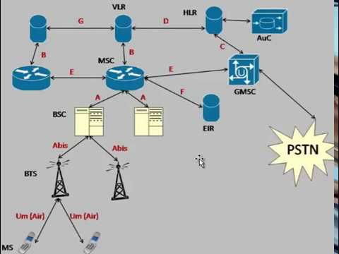

Fig 2.12 Diagram Architecture of a Mobile Switching Centre (MSC) [6]

**2.3.9 GSM Network**

GSM network is a radio network distributed over land areas called cells, each served by at least one fixed transceiver station, known as cell site or base station.

GSM module converts voice, text, multi-media messages, or data cells into Radio Frequencies (RF). Mobile phone’s base transceiver station transmits and received the RF signals and connects the caller to other phones and other networks

**2.3.9.1 Types of Channels in GSM Network**

There are two types of channel used in GSM communication;

**2.3.9.1a: Control Channel:** This channel is to ensure handover procedure works; the phone constantly monitors the broadcast control channel up to 16 neighbouring cells. In normal operation, the phone continuously adjust the power of the radio waves, they set out to be the minimum needed for the base station to receive a clear signal. If a phone moves far away from its base station, the signal is weak; the network consults the list and triggers a handover to a neighbouring cell with the best signal.

**2.3.9.1b: Traffic Channel or Voice Channel:** The traffic or voice channel is a channel that carries calls or active data from the mobile phone or GSM module to the base station and vice-versa. In the traffic channel, voice or text data are carried in bursts. Each burst comprises of two consecutive strings of bits (a series of signals representing Input signal (IS) and Output Signal (OS)), each 57 bits long.

**2.3.10 Signal Range**

The range within which mobile or GSM module is connecting to a signal is not a fixed range. It depends on a number of factors like the frequency of use, the transmitter’s rated power, the transmitter’s size, and receiving power etc.

**2.3.10.1 Power Calculations**

Pr (d0) = Pt Gt Gr(ʎ/4πdo)2  ( reference: Introduction to mobile communication)

ʎ= C/F

Where Pr: Received power

Pt: Transmitted power

Gr: Receiver antenna gain

Gt: Transmitter antenna gain

ʎ: Wavelength

f: Frequency

c: Speed of light (constant) = 3×108m/s

d0: Distance between the mobile or the GSM module and the

Receiving antenna

**NOTE:** Frequency in this context means of how many times an electromagnetic waves travelled in a second.

**2.3.10.2 Frequency Reuse**

The frequency reuse technique is a very important tool for my project to perform its required function. Cellular phone network used cellular frequency reuse. In the cellular frequency reused concept, frequencies allocated to the service are reused in a regular pattern of areas called cells, each covered by one base station. To ensure that the mutual interference between users remains below a harmful level, adjacent cells are used. However, cells that are separated further apart, uses frequency reused.

**2.3.11 Multiple Access protocols**

In mobile communication, four main types of multiple access protocol are used to support effective communication. They are;

#### **2.3.11.1 Time Division Multiple Access (TDMA):** This is a channel access protocol that allows several users to share the same frequency channel by dividing the signal into different time slots periodically. The users transmit in rapid succession, one after the other, each using its own time slot.

#### **2.3.11.2 Code Division Multiple Access (CDMA):** This is a channel access protocol used by various radio communication technologies, which assigned different identification code or languages to different users simultaneously over a single

#### **2.3.11.3 Frequency Division Multiple Access (FDMA):** This is a channel access method used in multiple access protocol that divides the frequency to different geographical locations to satisfy the users using cellular communication channel.

#### **2.3.11.4 Space Division Multiple Access (SDMA):** This is the division of channel access points to different locations base on creating parallel spatial pipes next to higher capacity pipes through spatial multiplexing and /or diversity, by which it is able to offer superior performance in radio multiple access communication system. Communication channel into different time slots periodically. The users transmit in rapid succession, one after the other, each using its own time slot.

**2.4. Technical Descriptions and Working Principles of**

**OV7670 Camera Module**

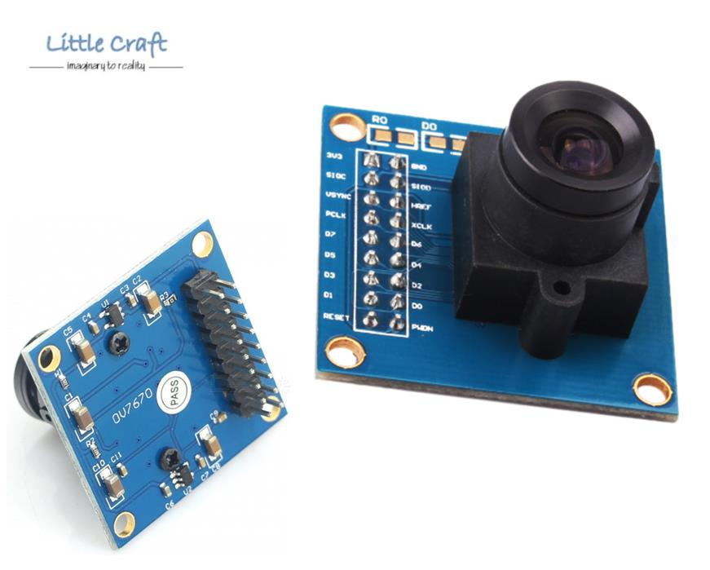

Fig.2.13 0V7670 Camera Module [2]

The OV7670 is a small image sensor that operates on a low voltage and provides all functionality of a single chip of (Video Graphics Array) VGA camera and image processor. It provides full-frame, sub-sampled or window 8-bit image in various formats, controlled through the Serial Camera Control BUS (SCCB) interface. This module is powered from a single +3.3v power supply, and external clock source for the camera module XCLK pin. It is used with Arduino, it has an array capable of operating at up to 30 frames per second (fps) in VGA 640×480 resolution with complete user control over quality, formatting and output data transfer.

This project provides very good image capturing solution that can be used in real-time, time-lapse photography, image acquisition systems or as security cameras.

The camera module is accessed by SCCB (Serial Camera Control Bus) I2C protocol by the Arduino. The Data sent by the camera is parallel over the data channel D0-D7, Data received by the Arduino is sent to the computer over serial communication and this follows the rule of sending Pixel data of one row at a time. This help to overcome the problems of slow processing and slow data transmission rate of the Arduino board.

**2.4.1 Camera Module specification**

|  |  |
| --- | --- |
| Resolution | VGA (640*480); QVGA (320*240); CIF (352*240); QCIF (176*144) |
| Transfer Rate | UP to 30fps |
| Image Encoding | RGB 565/555; YUV/YCbCr4: 2:2 |
| Interface | I2C Interface interaction /SCCB |

**2.4.2 Applications of Camera Module (OV7670)**

Some of the application of camera module are; PC camera, cellular phones, video conference equipment, machine vision, security camera, biometrics, digital still cameras.

**2.4.3 Functions of The 0V7670 Camera Module**

These camera module performed image processing such as Auto White Balance (AWB), Automatic Exposure (AE) and Automatic Gain Control (AGC) for the video signals it intercept. It supports motion, whenever the PIR sensor detects a movement, the Arduino triggers the input of the camera module through TTL communication and the camera focuses its lens, send photons in the direction of the movement, capture the moving image, and store it in the SD card.

**2.5 Technical Descriptions and Working Principles of The SD Card Module**

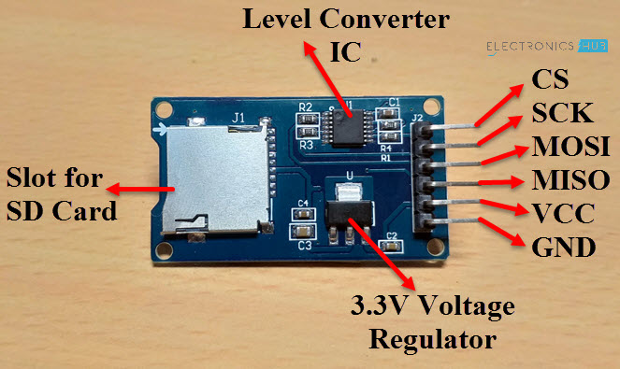

Fig 2.14. SD Card module [5]

The Arduino SD card module is an SPI communication base device; it can store different kind of data types from images to videos. SD cards generally are 3.3V logic but with this SD card module, the signals are converted to 5V via logic level converted implemented on the SD card module. As earlier stated, communication with the Arduino over SPI (Serial Peripheral Interface) communication protocol and it is connected to the Arduino hardware SPI pins.

**2.5.1 Functions of The SD Card Module**

This device is used in with Arduino and it used to provide some sort of external storage for microcontroller, and microprocessor based projects, to store different kind of data types from images to videos. Whenever the camera module captures an image, it sends it to the SD card for storage and those images can be access later by the user from the SD card.

**2.5.2 Features of SD Card Module**

1. Input Voltage: 3.3V/5V
2. With all SD SPI Pins out :MOSI, SCK, MISO and CS ,for further connection
3. Through programming, you can read and write to the SD card using your Arduino
4. Make your SD application more easier and simple
5. Communicate with Arduino using SPI interface
6. Push-pop socket with card slightly over the edge of the PCB so it’s easy to insert and remove
7. 4 mounting holes with 2.2mm diameter
8. Only use 4 I/O pins on the Arduino
9. Size: 42mm x 25mm x 5mm

**2.6 Methodology (System Implementation)**

**2.6.1 Interfacing The PIR Motion Sensor with Arduino UNO**

The method of interfacing and assembling this system as shown below, start by the PIR sensor Module and the Arduino UNO. The PIR sensor Module has only three pins – one is Vcc which is a +5 volts input, a ground pin and finally the digital output pin. Connect +5V from Arduino to Vcc of PIR sensor module, connect a GND from Arduino to ground of PIR sensor and finally connect the output pin (marked as ‘out’) to any digital pin 13 of Arduino. In our circuit diagram, we have connected it to pin seven (7) of Arduino.

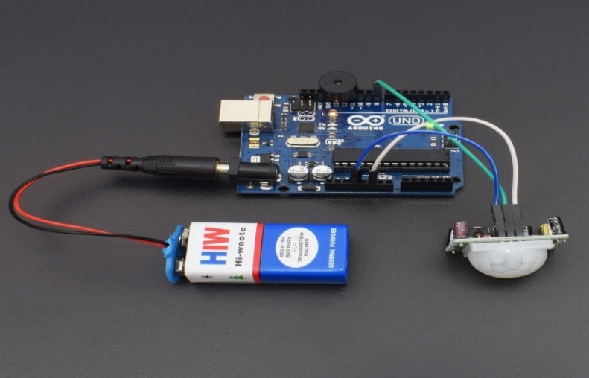

Fig. 2.15 Interfacing PIR motion sensor with Arduino UNO [7]

**2.6.2 Interfacing The SIM 900 GSM Module with Arduino UNO**

To Interface the GSM Module with the Arduino, an alternate method is used in which the two digital pins of Arduino for serial communication are used. The transmitting pin (Tx) of the GSM module is connected to the receiving pin (Rx) of the Arduino. The Rx pin of the GSM module is connected to the Tx pin of the Arduino (GSM Tx→Arduino Rx and GSM Rx→Arduino TX). Then the ground pin of the Arduino is connecting to the ground pin of the GSM module. After the completion of these connections, a program is loaded to start the data transfer from the Arduino to the GSM module. The Rx and TX wiring is disconnected each time a program to be burn in the Arduino and once a program is load successfully; the Pins can reconnected.

This method is made possible with the [SoftwareSerial Library](http://arduino.cc/en/Reference/softwareSerial) of Arduino. SoftwareSerial is a library of Arduino, which enables serial data communication through other digital pins of Arduino. The library replicates hardware functions and handles the task of serial communication.

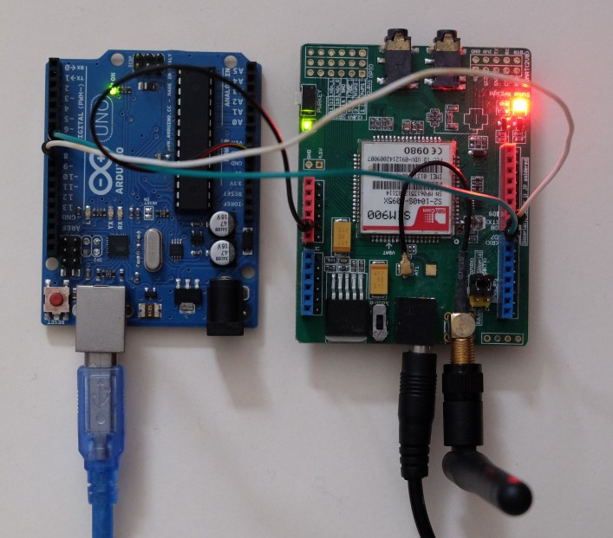

## Fig. 2.16 Interfacing the SIM900 GSM module with the Arduino UNO [7]

**2.6.3 Interfacing The OV7670 Camera Module with Arduino UNO**

The interfacing starts with **including required library necessary for OV7670**. Since OV7670 runs on I2C interface, it includes <util/twi.h> library. The libraries used in this project are built-in libraries of Arduino IDE. I just included the libraries to get the job done. I tried to use jumpers as short as possible; I used 3.3V Input for OV7670 as exceeding voltage than this can damage the OV7670 module.

After this, I modified the register need for OV7670. The program is divided into small functions for better understanding.

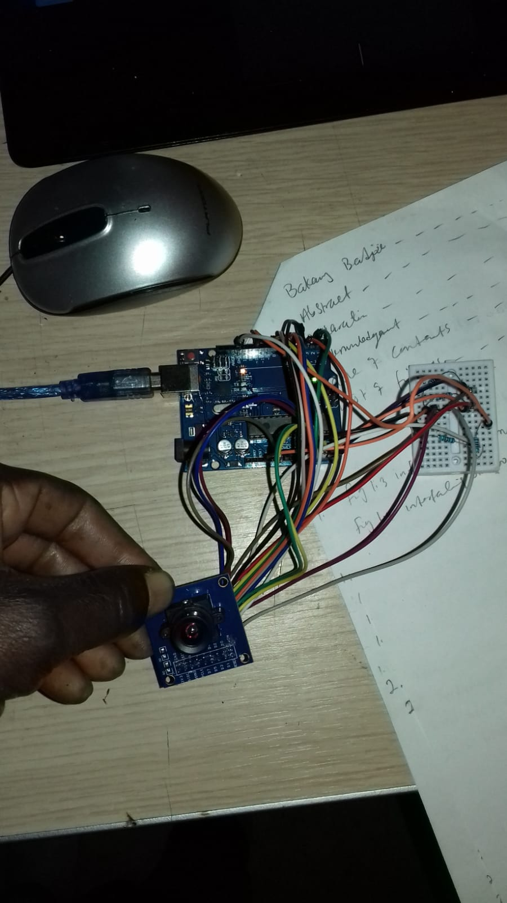

Fig. 2.17 Interfacing OV7670 camera module with Arduino UNO [2]

**2.6.4 Interfacing The SD Card Module with Arduino UNO**

The Arduino has a serial output pin, a serial input pin, a clock pin, and an enable pin to select the memory. All the information is transferred through one Data line to the SD card, and one Data line back to the Arduino’s CPU.

* VCC is connected to the 5V of the Arduino.
* Then, the GND of SDcard is connected to the ground of Arduino.
* Connect CS to pin 14.
* Connect SCK to pin 13.
* MOSI connect to the pin 11.
* Lastly, connect MISO to pin 12.

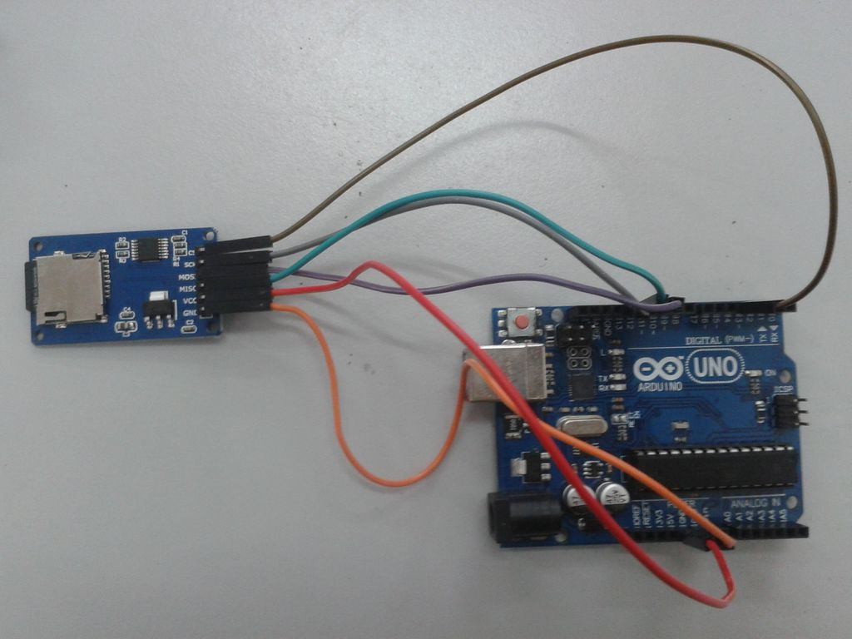

Fig. 2.18 Interfacing SD card module with Arduino [5]

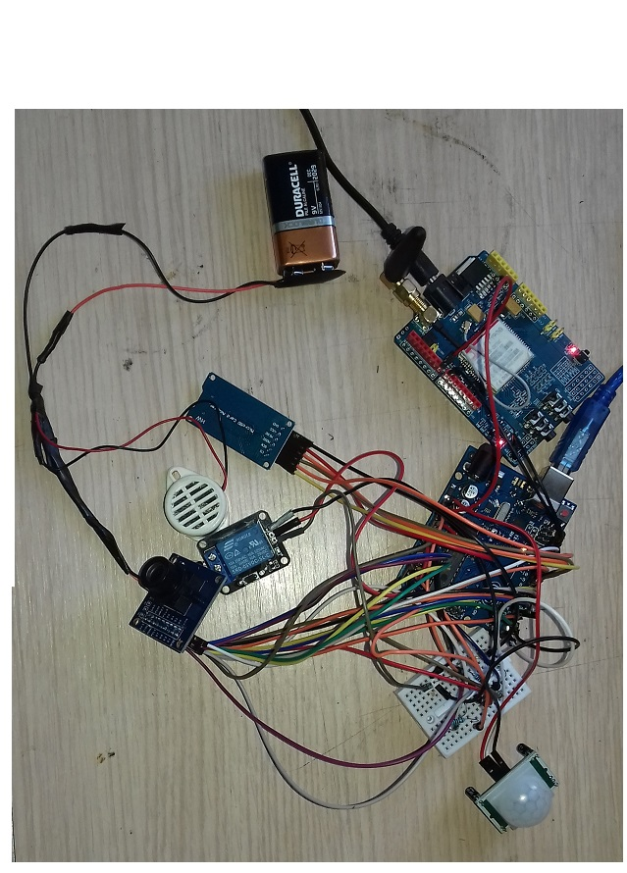

(a)

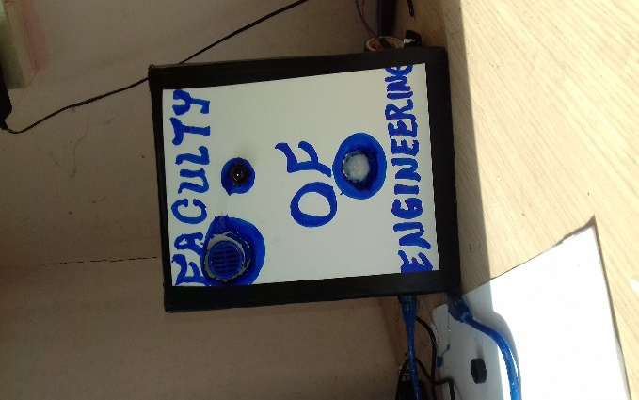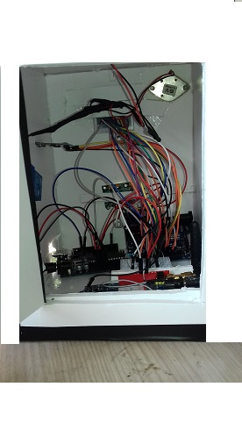

(b)

Fig. 2.19 complete picture of the system depicted in (a&b)

**2.6.5 Concept and Operations of The Project**

Adopting central controller to control the whole process of providing security to homes, offices, banks, and other restricted places achieves this security system. The mains aspects of this system is the sensory system that collects the parameter’s information (human) and send the corresponding logic data to the microcontroller or any other processor with an intermediate circuitry like Analog to Digital converter (ADC). This microcontroller is programmed in such a way that when a logic data is sent into it, it sends commands to the GSM module through serial data communication.

The GSM module allows the system to communicate to the user over the mobile network through text messages; the GSM module consists of a SIM card that operates over a subscription through a mobile network. The 0V7670 camera module is used to capture images in a covered area and the SD card is used for the storage of those images captured by the camera.

The Arduino communicate with the GSM module using **“AT command.”** AT commands are interfacing commands that enable the Arduino to transfer serial information to the GSM module using serial communication functions provided by the Arduino library and the GSM respond will be **“OK”** when it receives the command “AT” and it is the best way to check communication between the module and the microcontroller. The command that enable the GSM module to send text messages to a specified mobile phone number is **“ATD.”**For example; **ATD+905338374967**

**2.6.6 Block Diagram of The System**

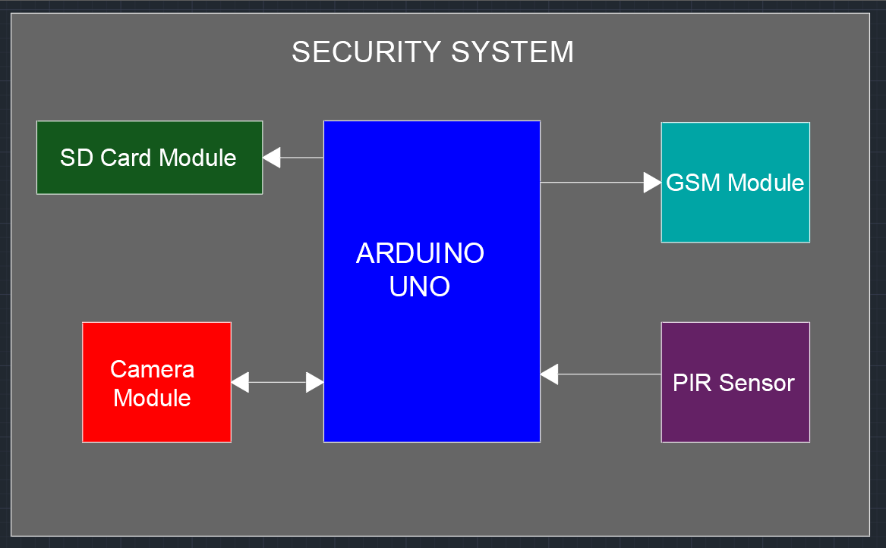

Fig: 2.20 Block Diagram of the Security System [8]

**2.6.7 Circuit Diagram of The System**

The proteus simulation of the system and it mode of connections

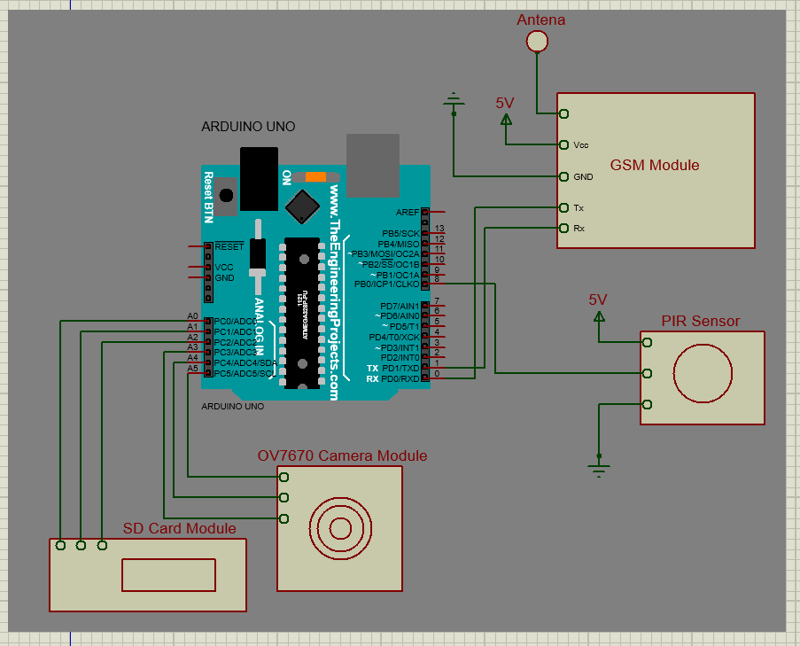

Fig 2.21: Systematic circuit diagram of the system [8]

**2.6.8 Academic Honesty and Plagiarisms**

**2.6.8.1: Cheating** is copying from others students or providing information, written or oral to others.

**2.6.8.2: Plagiarisms** is copying without acknowledgement from other people’s work. According University bylaws cheating and bootlegging are serious offences punishable with disciplinary actions ranging from simple failure from the exam or project, to more serious actions, such as letter of official warning suspension from the university for up to a semester. Disciplinary action is written in student’s records and may appear in student’s transcripts.

**3.0 Social Effects of The Project**

The usage of this system contains no destructive substances that can be harmful to the society or to the user. The system only takes in infrared signals as its input and give out electromagnetic signals as an output, which have no destructive effect on the environment.

**Positive Effect:**

* This system offer stable and a peace of mind to the user as far as home security is concern as it notify the user whenever there is/are movement within its area of application.
* It provides tactical measures and formations to the security guides in their area of concern and enables them to respond to the situation as soon as possible
* With the help of this project, no one can invade your privacy without your knowledge. In addition, the phone call and text message alert is more economical because you will not need to hire many security guards to protect your premises or restricted areas.

**Negative Effect:**

* It occupy the frequency slot meaning occupying the communication traffic channel and not giving other users the chance to fit into the traffic when making an unnecessary call in the case of house when family members or anyone whom is not meant for come into its active range.
* It can interrupt the daily activities, work, or sleeping of the user when making undesired calls because the system is designed to be active if anyone comes into its range regardless of being a residents, intruders, or strangers.
* It is not also good to the environment as it used power to function that produces toxic fumes thereby destroying the environment.

**3.1 Economic Analysis**

As I made research on my proposed project, I went further to make enquires on the cost of each component I will use for my project and I calculated the cost of my project. The table below gives the cost of each material and the total cost.

|  |  |  |  |
| --- | --- | --- | --- |
| **Material** | **Cost** | **Place of Purchase** | |
| PIR motion sensor | $10.00 | [www.aliexpress.com](http://www.aliexpress.com) | |
| Arduino Uno complete set | $37.50 | [www.aliexpress.com](http://www.aliexpress.com) | |
| SIM900 GSM module | $60.00 | [www.aliexpress.com](http://www.aliexpress.com) | |
| 9volt DC power adopter | $5.00 | [www.aliexpress.com](http://www.aliexpress.com) | |
| Jumper cable(M-M and M-F) | $10 | [www.aliexpress.com](http://www.aliexpress.com) | |
| 0V7670 camera module  Arduino SD card module | $40.50 | [www.aliexpress.com](http://www.aliexpress.com) | |
| **Total cost** | **$163** | | **www.aliexpress.com** |

**3.2** **Manufacturing**

This project is not be manufactured for the purpose of business or retail, but for the partial fulfilment of my bachelor degree in electrical and electronic engineering. This project is be implemented to demonstrate how homes, offices, shops, banks, and other places can be secured from intruders.

**3.3 Sustainability**

To ensure sustainability, the device must be connected or installed in a proper order. Before turning on the device, you must check every point of connection between the components of the device. The device should be place in the area of good ventilation, keep away from strong electromagnetic sources with heat sources to ensure high isolation effect and stable operation for a long time. Do no remove or dismantle any connection while the device is working. Otherwise, the device effectiveness may be tampered with or the device will be damaged. Keep away from caustic gases and liquids. Be sure to make it waterproof, dust-proof and moisture-proof.

**3.4 Health and Safety**

Does PIR sensor and GSM based Security System do harm to human bodies and other devices? The answer is NO because the electromagnetic signal emitted by this device is very weak, hence would not do any harm to human bodies. At the same time, this system will not block off any other communication devices, it does not used any internet service to operate hence, have no effect on the data rate in order to cause overloading whereby making other devices not to work effectively.

**3.5 Ethics**

There should be no problem in using this kind of system for security measures. There should be no symbol or poster to indicate that the device is installed in a particular place. There are no problems for not disclosing the used of this system to your friends and neighbours. There is no illegality in the used of this system hence the system have no bad or harmful effect on human, animals and on the environment as well. It gave high level of privacy and provide high level of security to the users.

**3.6 Legal Issues**

There are no illegal issues regarding the use of this system for providing security as far as my research is concerned. In fact, this system help the government in the sense that it reduces the amount of fund spent on the security forces like the police and the other security agencies. Instead of the police to be using time and resources to be patrolling everywhere searching and monitoring intruders, this system can help them to easily locate the exact time and place of intrusion.

**4.0 Result and Discussions**

The test was successful, an alert was sent after 10 seconds. Figure 4.1 shows a small part of the process of this test. At the upper side of the figure, is the text message received by the user’s mobile phone. Followed by some of the images captured by the camera when motion was detected.

A short literature study was perform on automatic surveillance system to find out what the state of-the-art is. This short literature study gave a good overview of the field of surveillance. During the project, many other papers are found to help with specific problems and the survey papers helped to get grip on the basics and possibilities of automatic surveillance system.

The results of the image processing are good, keeping in mind that a basic object detection technique is chosen, the tracker is not yet tweaked in an attempt to improve results and the object classifier is expected to improve significantly with better.

As we tried our electronic device, the outcome was successful. The device could effectively detect human motion and send a test message to the user’s mobile phone; the system can send text messages to the two phone carries in north Cyprus; Trukcell and Telsim through a concept of cellular communication as well as effectively captured the moving image through the concept of digital image processing. The detection extent is around 7-12 meters. This is more than what was expected, the reason is that in our calculations, we considered the most pessimistic scenario of having the user’s phone near the base station but instead it can send text messages to the user’s mobile anywhere in the island, this is because of the way that the amount of power reaching the cell phone from the base station diminishes as the cell phone more distant from the base station.

**4.1 Advantages**

* Whether we install this system in your home or at the workplace, we can prevent crime from occurring. The mere sight of the camera staring back at them, and the sheer thought of getting caught red-handed are intimidating enough for mischief-makers to be on their best behavior, as they would know that their identity and illegal activity have been captured and will be notice where a quick response will be taken.
* Whether we are experiencing problems related to theft, punctuality, or productivity, this system can provide us with the solutions. It empowers us and prevents our home and office from becoming easy targets.
* In this system, there is a message and image integrity, these integrities are an important part of the system’s security. The message and the image cannot be modified or tempered with. In addition, if we are a victim of a burglary, the cameras will record the incident and help lead to the capture of the criminal and hopeful return of your stolen goods. This leads to our next point.
* In contrast, information security focuses on the completeness, confidentiality and timeliness of the information transmitted. Information security is vital for user’s applications concerning security and monitoring in the context of home and other important installations
* The system uses a communication channel to send these results to the user without the need of Wi-Fi and prevent intruders from invading any privacy without being noticed.

**4.2 Problems and Solutions**

* Initially, when we completed the interfacing the whole system, the system was given a false alert i.e. Even when there is no motion within its range of sensitivity. We later realized that, the signal pin of the PIR sensor was connected to the vcc 5V of the Arduino. We removed the signal pin of the sensor from the vcc and connected it to pin digital pin 13 of the Arduino.
* The GSM module was not sending any message i.e. it does not indicate the connectivity of network on it, even when the interfacing was properly done, this is because the module was not registered in north Cyprus in order to work with any of the GSM operators in north Cyprus. We went to Lefkosa, registered the module, and re-interfaced it again and now it is successfully sending text messages as expected.
* Using the code to test the SD card, we run the code and open the file using hex editor. It was success. However, we run the code for the camera and ran it; it captured a single bit per frame. The file was having error after the program was executed. We wrote a bmp file with proper headers and use the raw data i.e. One byte per pixel to fill the raw data in the bmp file and it is successfully capturing images without error.
* The mere presence of this system can deter criminals, but it is extremely dangerous to rely on system because seasoned burglars can typically spot them from a mile away. In most cases, thieves will case a home before they rob it, but if this system is installed with an alarm system in case the battery of our cell phone goes down or is away from us. If the intruders spot cameras installed by a professional alarm system, they will most likely abort the burglary attempt.
* The view of the camera is limited and the sensitivity of the PIR sensor is limited to certain distance.This means that once this system is installed, the camera and the PIR sensor are capable of keeping track of a certain angle and certain area of that particular area. The area is certainly very limited. If the vandals plan to disrupt the condition of a particular place, they might just change the direction of the sensor and the camera. Therefore, they can continue disrupting the normal state of that place. This can be solved by interfacing different sensors and cameras with one system and they be mounted at different areas and in different angles.
* Unfortunately, the issue of invasion of privacy arises with hidden surveillance cameras in public. Which begs the question: are security cameras in public places an invasion of privacy? The main complaint against surveillance cameras in public places is that, under the right circumstances and investigation, it could paint a complete picture of one’s private life that they may not want known. It does not mean that they are doing something illegal. It just means they want to keep their personal life “personal”.

Here are some of the images and text messages captured by the camera and received by the user’s mobile phone respectively.

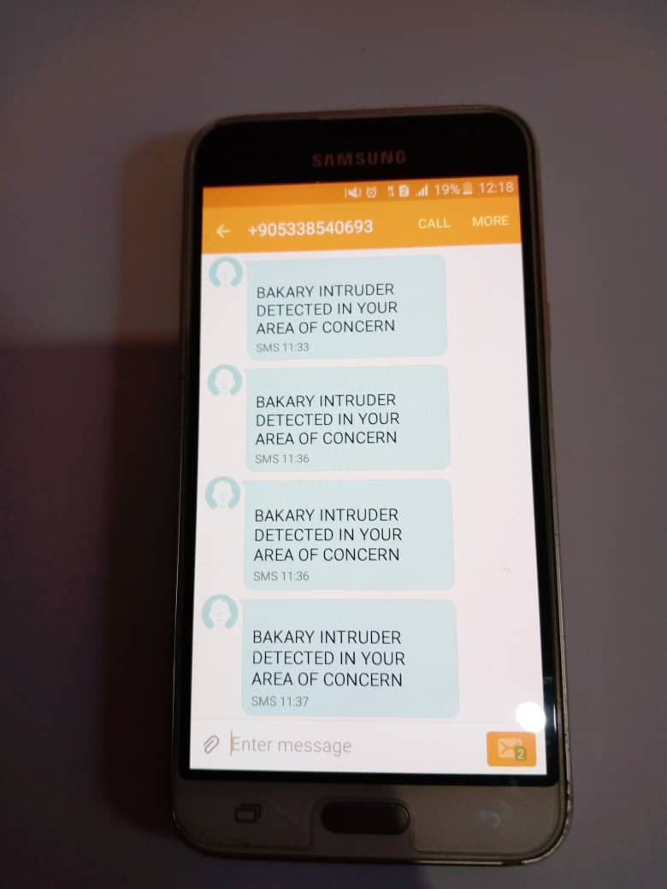 





Fig. 4.1 Demonstrations of results

**5.0 Conclusion**

**5.1. Summary**

This report has presented the theoretical and practical design of a security system. These described the design and construction of the system in such a way that maintenance and repairs can be easily carryout in terms of faults. The design of this system involves research in different aspects of physics and electronic technology; this includes telecommunication, networking, cellular communications, computer programming, software engineering, wireless communication, microprocessor theory, theory of electromagnetic wave propagations, and introduction to mobile communication, signal and system, Digital Image Processing etc.

The project is now practically designed to provide security for homes, banks, hospital, prisons, supermarkets, military barracks, safe houses and other restricted installations by sending a text message to the concerned persons via his or her mobile phone, in order to be alerted on intrusion situations. Today almost everyone is using mobile phone so by the use of this system, users will not have to carry additional device to monitor their homes and other places. In this project, the PIR sensor served as a movement detector, the Arduino board microcontroller as a signal-processing component, the SIM900 GSM module as a text-messaging device, the OV7670 camera module served as an image-capturing component and the SD card module as a data storage device.

In event of risk of intruders or vandalism from domestic properties, restricted installations, private places, commercial places, this project counter-act these situations by making a quick alert to the concerned persons. The overall developments of this project is a basic solution for the growing security concern.

## 5.2 Evaluation

During the implementation of the project there may be errors if the connections are integrated incorrectly, insufficient voltage supply to reach appropriate components especially the 5VDC to 12VDC to power-up the Arduino, interfacing the circuit without proper check-up for accurate signal levels between the devices, currents levels and frequencies of its operations, there can be coding errors due to inappropriate codes since the codes are not originally designed by me, there is not be enough time to fully concentrate on the project since there other academic commitments to accomplish during the semester and also since the security system is finally implemented and placed where visible in desired places e.g. Homes, banks, offices and other necessary places, this device can be removed or stolen by individuals.

These obstacles can be solved by proper checking the supply voltage or voltages painstakingly and ensure that they reach the proper segments especially the voltage required to power the Arduino, on the off chance, proper interfacing and the used of correct codes, appropriately check the operation of the circuit in the different stages when in doubt take after the course of the signal, frequently using the software needed for the system and trying to solve more challenging problems as possible and after implementation, keep device where it cannot be visible to avoid being tempered with.

**5.3 Future Work**

The PIR sensor and GSM based security system are used for providing security for any desire places therefore it can be useful for security based operation areas.

This project can be reached out by utilizing GPS, 3G, 4G technologies and image processing technologies. Through GPS, we can monitor the area from anywhere on the planet and 3G, 4G, and 5G can be at some specific security timings by using the internet service and, it can be interface with a video camera to take the video of the covered area and the intruder in action, instead of using only the camera to capture only the image.

**References**

**[1]**Chowdhury ZI, Imtiaz MH, Azam MM, Sumi MR, Nur NS. Design and implementation of pyroelectric infrared sensor based security system using microcontroller. In Students' Technology Symposium (TechSym), 2011 IEEE 2011 Jan 14 (pp. 1-5). IEEE.

**[2]** [Aparicio, J. Hacking the OV7670 camera module.](http://embeddedprogrammer.blogspot.in/2012/07/hacking-ov7670-camera-module-sccb-cheat.html)

**[3]**Focusing devices for pyroelectric infrared sensors [Online]. Available from: <http://www.glolab.com/focusdevices/focus.html> [accessed Sep 22, 2017].

**[4]**Dhake PS, Borde SS. Embedded Surveillance System Using PIR Sensor. International Journal of Advanced Technology in Engineering and Science. 2014 Mar; 2 (3).

**[5]** Aparicio, J. Hacking Arduino VS SD card interface (serial peripheral interface)

**[6]** Michel. M and Bernadette. P (2002) GSM system for mobile communication 2nd Edition

**[7]** Simon. M. (2013) 30 Arduino project for Evil Genus 2nd Edition

**[8]** Proteus simulations

**Appendix A**

* **TTL serial communication:** This method of communication is known as Transistor-Transistor Logic. The serial communication at this level most often remain between the limits of 0V and VCC, which is usually 5VDC to 3.3VDC a logic high (‘1’) is represented by VCC while a logic low (‘0’) is 0V.
* **2G network:** In short, 2G is for second-generation cellular technology. All data sent over a 2G network are digitally encrypted in such a way that one the intended receiver can have access to the data.
* **ATmega328P:** This is a single chip microcontroller created by Atmel in the megaAVR family. It has a modified Harvard architecture 8-bit RISC processor core.
* **SD Card** (Secure Digital **Card**) is an ultra-small flash memory **card** designed to provide high-capacity memory in a small size.
* **RS232 Port:** This is a protocol widely used for connections between data acquisition devices and computer. As in the definition of RS232, the computer is data transmission equipment (DTE).
* **“AT” commands**: These the instructions used to command the module. AT is the abbreviation of Attention. All commands start with “AT.” That is why it is called “AT “command. AT is the prefix each command to inform the module about the start of the command.
* “**ATD**” **commands:** These commands enable the module to initialize a call to the prescribed mobile phone number. It uses hyperactive terminal of a computer to send the above-mentioned commands to the GSM module through the serial port. If the module work on TTL technology, which I am not planning to use, and for the microprocessor high logic 12 Volt and the GSM module 5Volt to match, then MAX232 which is a voltage level converter IC (Integrated Circuit) that will be used to convert the voltage level between the microcontroller and the GSM module. The speaker should be able to give available dialling tone and the mobile phone that the GSM module is calling should ring.

#### **The code**

#### *int Relay = 13;*

#### *int inputPin = 2;*

#### *int PIR_STATE = LOW;*

#### *int VALUE = 0;*

#### *void setup() {*

#### *pinMode(RELAY, OUTPUT);*

#### *Serial.begin(9600);}*

#### *void loop(){*

#### *VALUE = digitalRead(inputPin);*

#### *if (VALUE == HIGH) {*

#### *digitalWrite(RELAY, HIGH);*

#### *if (PIR_STATE == LOW) {*

#### *// we have just turned on*

#### *Serial.println("BAKARY INTRUDER IS DETECTED IN YOUR AREA OF CONCERN")*

#### *PIR_STATE = HIGH;*

#### *} else {*

#### *digitalWrite(RELAY, LOW);*

#### *if (PIR_STATE == HIGH){*

#### *// we have just turned of*

#### *Serial.println("Motion has been stopped!");*

#### *PIR_STATE = LOW*

#### *}*

#### *}*

#### *}*

#### *const int Input1=8;*

#### *int State1=0;*

#### *void setup(){*

#### *Serial.begin(9600);*

#### *pinMode(Input1, INPUT);}*

#### *void loop(){*

#### *State1= digitalRead(Input1);*

#### *if(State1 == HIGH){*

#### *sendsms();*

#### *delay(2000);}}*

#### *void sendsms(){*

#### *Serial.println("AT\r");*

#### *delay(1000);*

#### *Serial.println("AT+CMGF=1\r");*

#### *delay(1000);*

#### *Serial.println("AT+CMGS=\"+905338374967\"\r");*

#### *delay(1000);*

#### *Serial.println("BAKARY INTRUDER IS DETECTED IN YOUR AREA OF CONCERN");*

#### *delay(1000);*

#### *Serial.println((char)26);*

#### *delay(100)*

#### *}*

#### *void WriteOV7670(byte regID, byte regVal){*

#### *// Slave 7-bit address is 0x21.*

#### *// R/W bit set automatically by Wire functions*

#### *// dont write 0x42 or 0x43 for slave address*

#### *Wire.beginTransmission(0x21);*

#### *// Reset all register values*

#### *Wire.write(regID);*

#### *Wire.write(regVal);*

#### *Wire.endTransmission();*

#### *delay(1);*

#### *}*

#### //Reading from OV7670

#### *void ReadOV7670(byte regID){*

#### *// Reading from a register is done in two steps*

#### *// Step 1: Write register address to the slave*

#### *// from which data is to be read.*

#### *Wire.beginTransmission(0x21); // 7-bit Slave address*

#### *Wire.write(regID);  // reading from register*

#### *Wire.endTransmission();*

#### *// Step 2: Read 1 byte from Slave*

#### *Wire.requestFrom(0x21, 1);*

#### *Serial.print("Read request Status:");*

#### *Serial.println(Wire.available());*

#### *Serial.print(regID,HEX);*

#### *Serial.print(":");*

#### *Serial.println(Wire.read(),HEX);*

#### *//*Initialize OV7670

#### *void Init_OV7670(){*

#### *//Reset All Register Values*

#### *WriteOV7670(0x12,0x80);*

#### *delay(100);*

#### *WriteOV7670(0x3A, 0x04); //TSLB*

#### *WriteOV7670(0x13, 0xC0); //COM8*

#### *WriteOV7670(0x00, 0x00); //GAIN*

#### *WriteOV7670(0x10, 0x00); //AECH*

#### *WriteOV7670(0x0D, 0x40); //COM4*

#### *WriteOV7670(0x14, 0x18); //COM9*

#### *WriteOV7670(0x24, 0x95); //AEW*

#### *WriteOV7670(0x25, 0x33); //AEB*

#### *WriteOV7670(0x13, 0xC5); //COM8*

#### *WriteOV7670(0x6A, 0x40); //GGAIN*

#### *WriteOV7670(0x01, 0x40); //BLUE*

#### *WriteOV7670(0x02, 0x60); //RED*

#### *WriteOV7670(0x13, 0xC7); //COM8*

#### *WriteOV7670(0x41, 0x08); //COM16*

#### *WriteOV7670(0x15, 0x20); //COM10 - PCLK does not toggle on*

#### *HBLANk*

#### //Initialize QVGA

#### *void Init_QVGA(){*

#### *WriteOV7670(0x0C, 0x04);//COM3 - Enable Scaling*

#### *WriteOV7670(0x3E, 0x19);//COM14*

#### *WriteOV7670(0x72, 0x11);//*

#### *WriteOV7670(0x73, 0xF1);//*

#### *WriteOV7670(0x17, 0x16);//HSTART*

#### *WriteOV7670(0x18, 0x04);//HSTOP*

#### *WriteOV7670(0x32, 0xA4);//HREF*

#### *WriteOV7670(0x19, 0x02);//VSTART*

#### *WriteOV7670(0x1A, 0x7A);//VSTOP*

#### *WriteOV7670(0x03, 0x0A);//VREF}*

|  |  |
| --- | --- |
|  |  |

1. //Saving Data on SD Card
2. *void QVGA_Image(String title){*
3. *int h,w;*
4. *File dataFile = SD.open(title, FILE_WRITE);*
5. *while (!(PIND & 8));//wait for high*
6. *while ((PIND & 8));//wait for low*
7. *h = 240;*
8. *while (h--){*
9. *w = 320;*
10. *byte dataBuffer[320];*
11. *while (w--){*
12. *while ((PIND & 4));   //wait for low*
13. *dataBuffer[319-w] = (PINC & 15) | (PIND & 240);*
14. *while (!(PIND & 4));  //wait for high*
15. *while ((PIND & 4));   //wait for low*
16. *while (!(PIND & 4));  //wait for high*
17. *}*
18. *dataFile.write(dataBuffer,320);*
19. *}*
20. *dataFile.close();*
21. *delay(100);*
22. *{*
23. **//**Writing a Bitmap Image File
24. *import csv*
25. *import sys*
26. *import binascii*
27. *csv.field_size_limit(500 * 1024 * 1024)*
28. *columnvector = []*
29. *with open('data.csv', 'rb') as csvfile:*

}